1. **Download Arduino IDE**

When getting this control board, we need to install Arduino IDE

Navigate the website <https://www.arduino.cc/>

Clickand

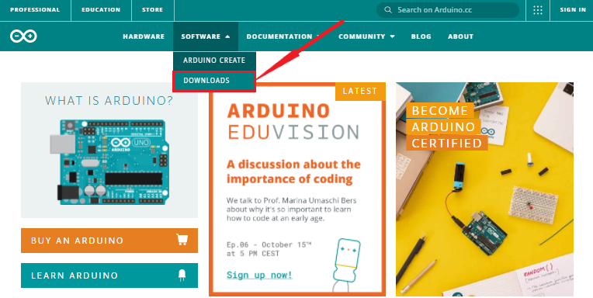

Select the version you want to download, the latest version could be downloaded.

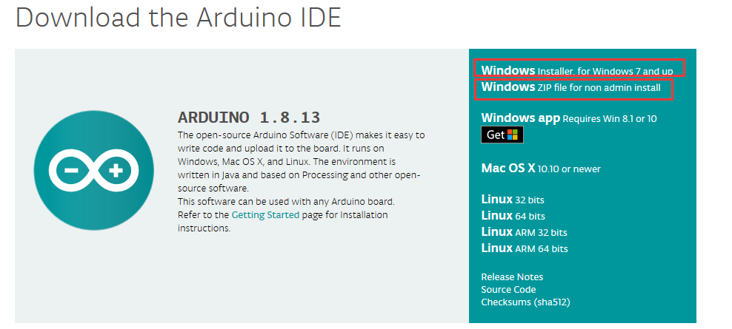

We will demonstrate how to download Arduino IDE in Windows system.

You could click to download an installer of Arduino 1.8.13 version, which needs to be installed manually.

When you tap，a zip file of Arduino 1.8.13 version will be directly downloaded, and you only need to unzip it to finish installation.

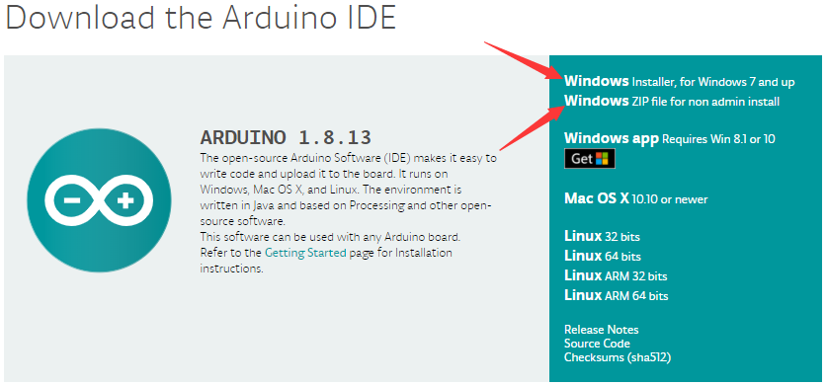

Click  to download an installer of Arduino 1.8.12 version，which needs to be installed manually. When you tap，a zip file of Arduino 1.8.12 version will be directly downloaded, and you only need to unzip it to finish installation.



Click icon to download Arduino IDE.

## **Install Arduino IDE**

Double-click arduino-1.8.13-windows.exe，and click I Agree.

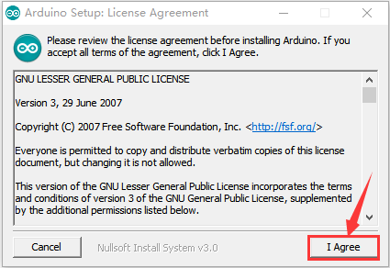

Click the components( Insall Arduino software）you want to install, and click Next to continue.

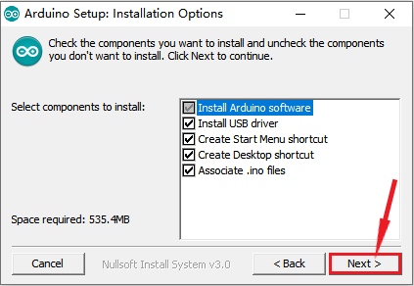

Click Browse and select the folder where **Arduino IDE file locates** and click Install.

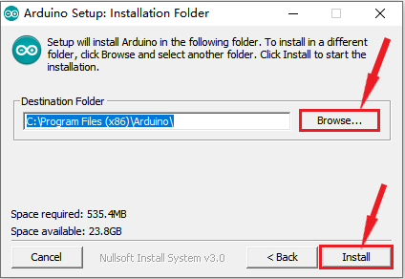

Wait for a while and click Close.

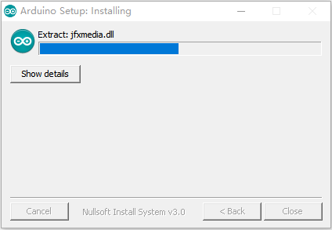

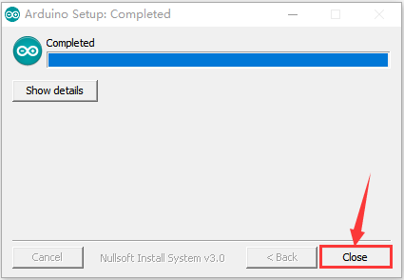

1. **Install Driver**

Let’s install driver after the download is finished. The USB to serial port chip of this control board is CH340G. So you need to install the driver for the chip.

If your computer is Windows10，connect the board to your computer, right-click*“Computer”—>“Properties”—>“Device manager”*,

You could view“USB2.0-Serial”below“Other Devices”.

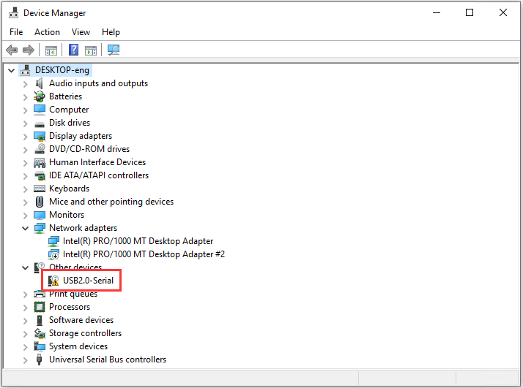

After a while, the driver USB-SERIAL CH340 will be installed automatically.

If not, you need to install manually, right-click“**USB2.0-Serial**”and tap “**Update Driver**”->“**Search automatically for updataed driver software**”.

Then wait for installation and click“Close”

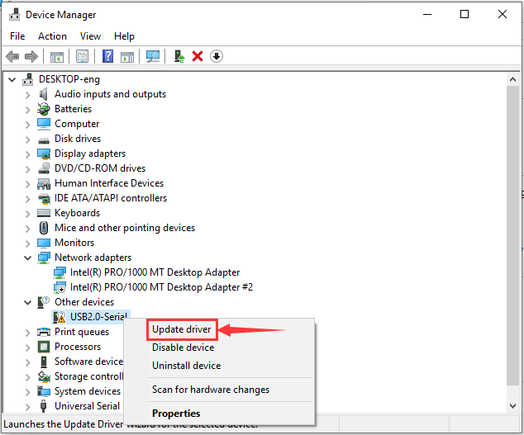

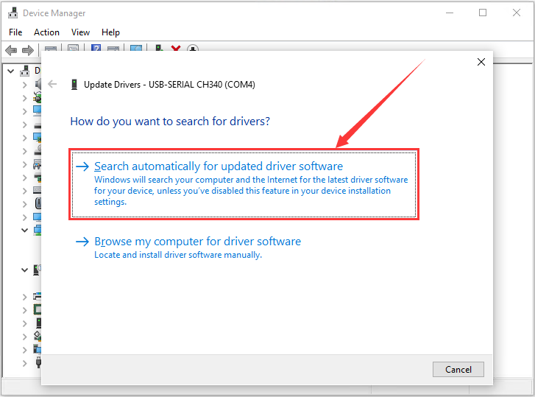

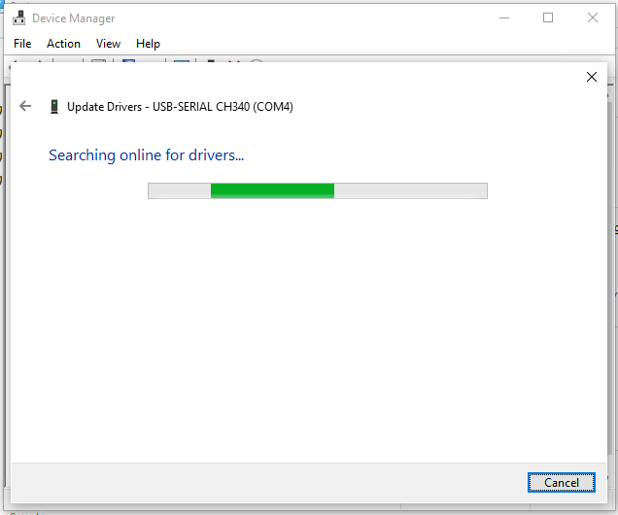

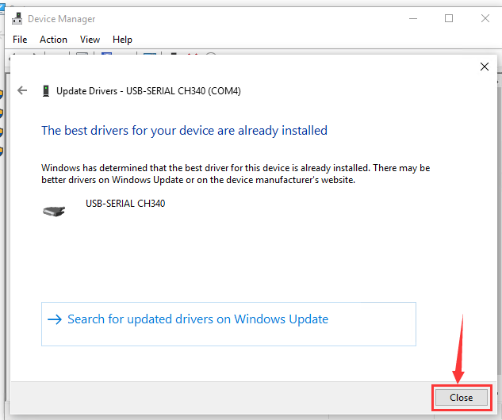

*Right-click“Computer” —>“Properties”—>“Device manager”, and tap port to check.*

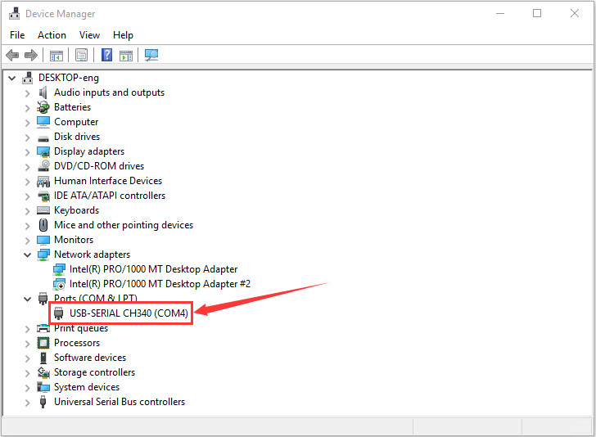

If your system is not Windows 10, you need to install driver manually.

**Other Windows System**

driver:“usb_ch341_3.1.2009.06”

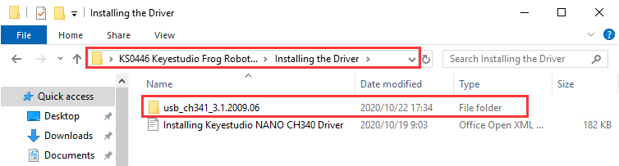

When you connect the board to your computer at the first time, right click *“Computer” —>“Properties”—>“Device manager”*, you will view “USB2.0-Serial”under“Other Devices”, as shown below:

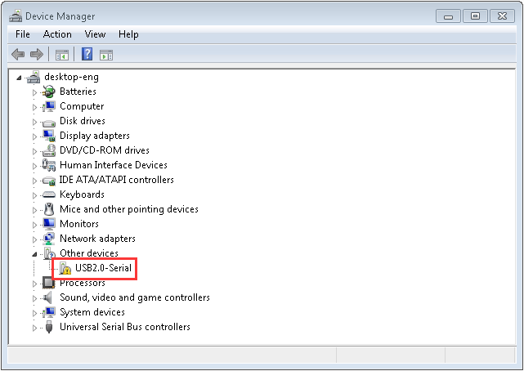

Then right-click on the device and select the top menu option (Update Driver Software...) shown as the figure below.

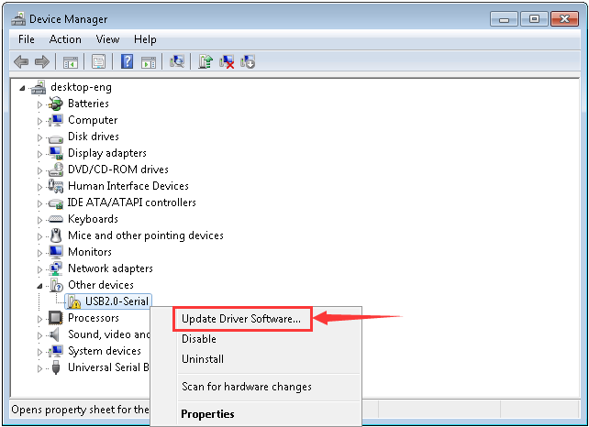

It will then be prompted to either“Search Automatically for updated driver software” or “Browse my computer for driver software”. Shown as below. In this page, select“Browse my computer for driver software”.

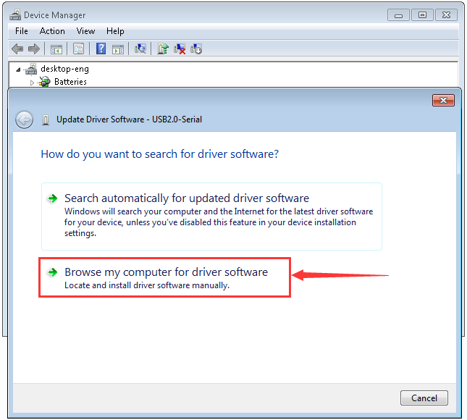

点击“浏览”，找到驱动程序文件夹，点中“usb_ch341_3.1.2009.06”驱动文件夹并单击“OK”，然后点击“下一步”。（我们把“usb_ch341_3.1.2009.06”驱动文件夹是放在KS0446 Keyestudio Frog Robot for Arduino Graphical Programming文件夹中Installing the Driver的文件夹中，你可以跟着我们的路径走，如下图：）

Click Browse to navigate the driver folder, select“usb_ch341_3.1.2009.06”folder and “OK”(we put“usb_ch341_3.1.2009.06”folder in the Installing the Driver folder)

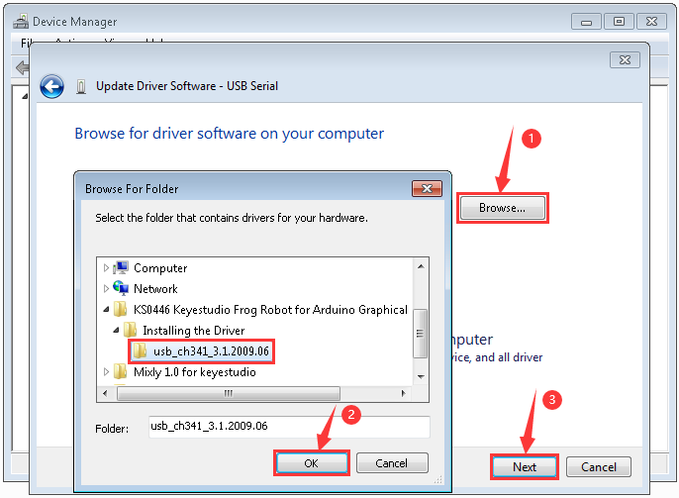

Click Next，once the software was installed, you will get a confirmation message. Click“Close”after installation completed.

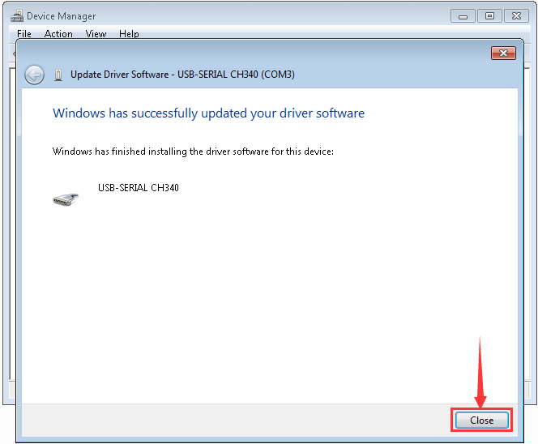

Up to now, the driver is installed well. Then you can right click “*Computer” —>“Properties”—>“Device manager”*, you should see the device as the figure shown below.

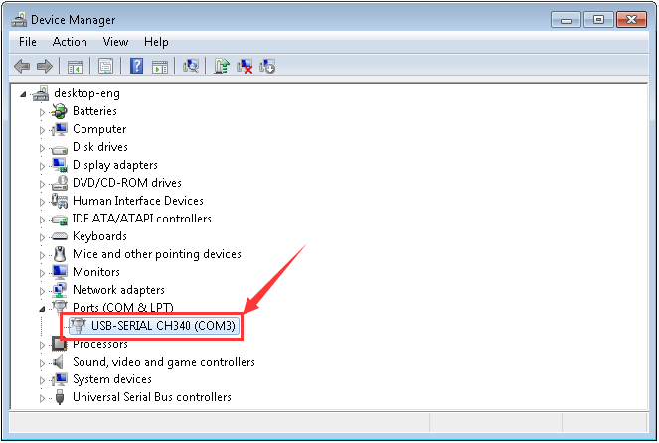

1. **Arduino IDE Setting**

Clickicon，open Arduino IDE.

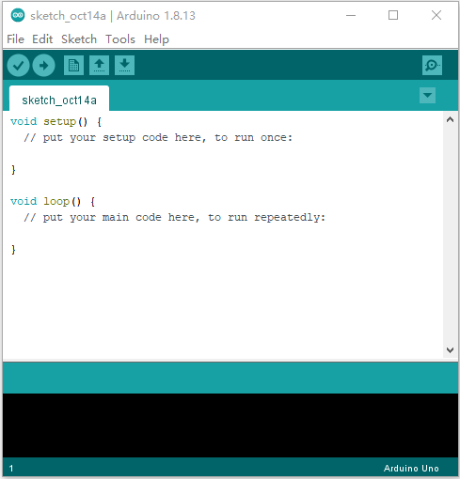

To avoid the errors when uploading the program to the board, you need to select the correct Arduino board that matches the board connected to your computer.

Then come back to the Arduino software, you should click Tools→Board, select the board.(the development board we use is NANO board, therefore, select **Arduino Nano)**

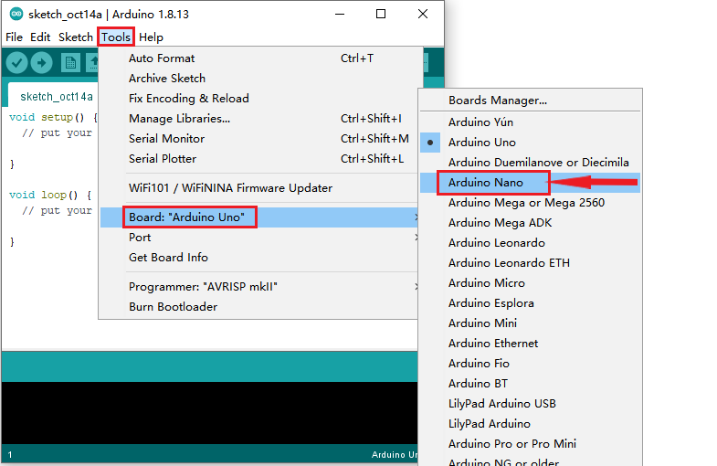

Then select the correct COM port (you can see the corresponding COM port after the driver is successfully installed)



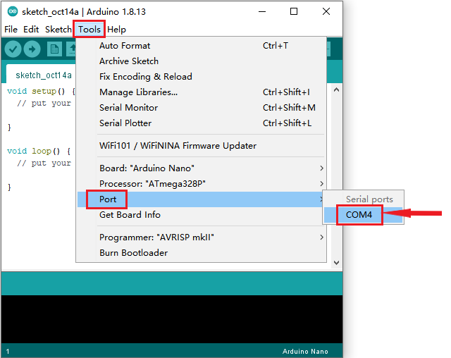

Before uploading the program to the board, let’s demonstrate the function of each symbol in the Arduino IDE toolbar.

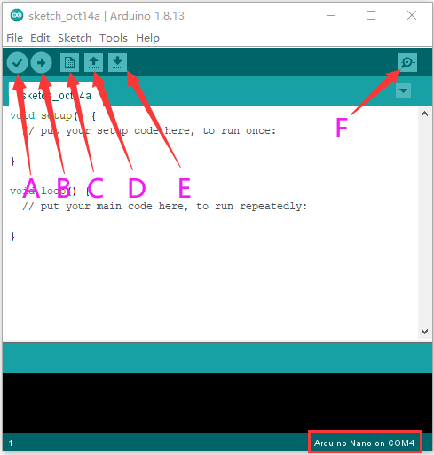

A- Used to verify whether there is any compiling mistakes or not.  
B- Used to upload the sketch to your Arduino board.  
C- Used to create shortcut window of a new sketch.  
D- Used to directly open an example sketch.  
E- Used to save the sketch.  
F- Used to send the serial data received from board to the serial monitor.

**(5) Start Programming**

Open the file to select Example, choose BLINK from BASIC, as shown below:

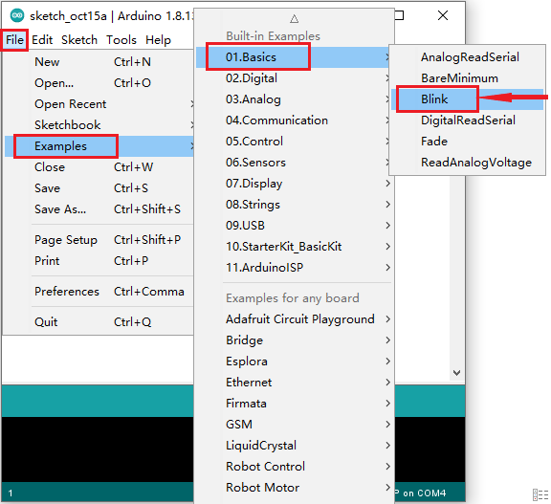

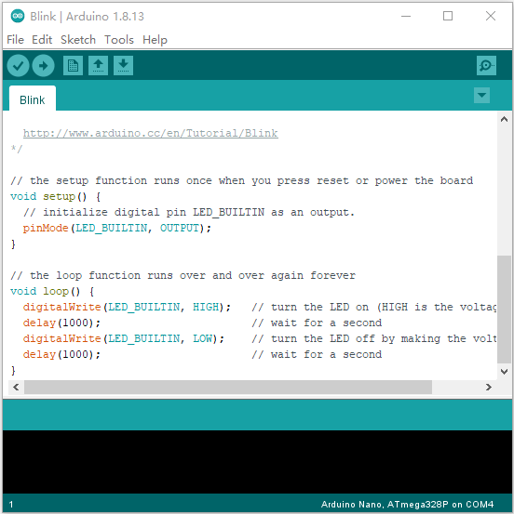

Set board and COM port, the corresponding board and COM port are shown on the lower right of IDE.

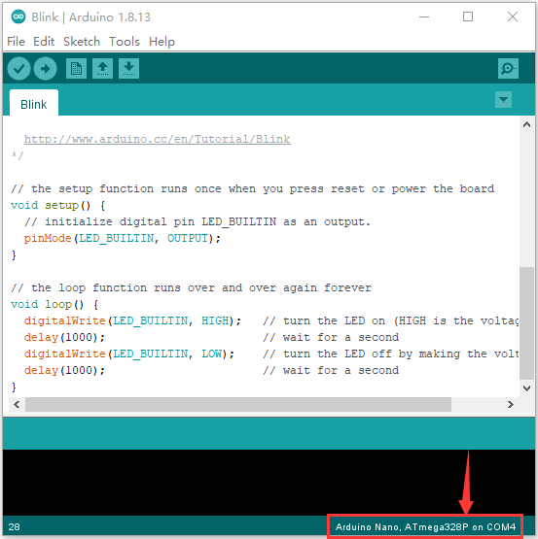

Clickto start compiling the program, check errors.

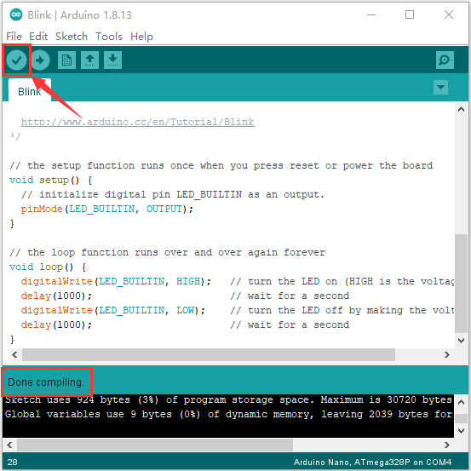

Clickto upload the program, upload successfully.

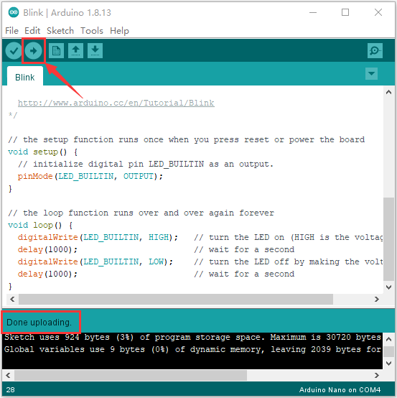

Upload the program successfully, the on-board LED lights on for 1s, goes off for 1s. Congratulation, you finish the first program.